There is no worklist. All user tasks use the default timeout endpoint.

The log server is running on port 12233(https://lehre.bpm.in.tum.de/ports/12233/) by me. If it is shut down, please run the file log.js in the folder public_html with command: node log.js

The log is stored in file log.yaml(https://lehre.bpm.in.tum.de/~ga94hor/log.yaml), which has pre-written header attributes.

LOG Visualization
Please visit https://lehre.bpm.in.tum.de/~ga94hor/data.html
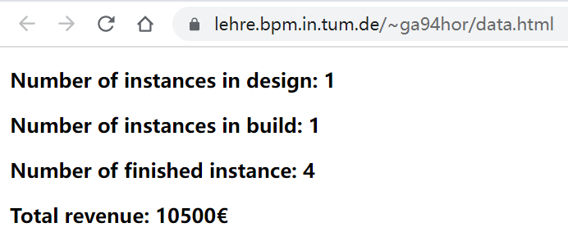
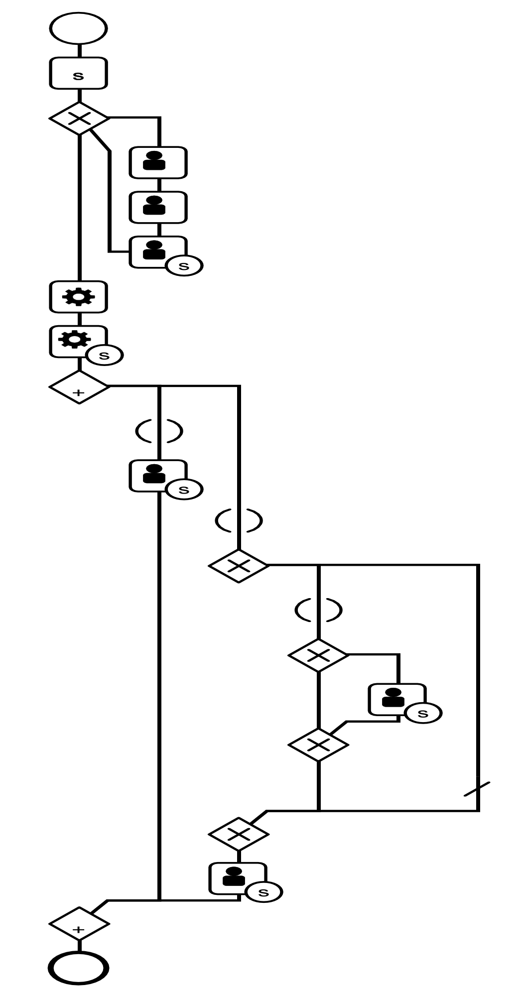
The data is displayed as text showing the number of instances at different stages and the total revenue for all instances.

